Price Optimisation Project: Bikaneri Bhujia 1 kg
Prepared for the Bishanlal Babulal pricing project | 11 October 2026 | Status: working draft, built on synthetic demand data

1. Summary
This project recommends a shelf price for 1 kg Bikaneri Bhujia by combining unit economics, demand elasticity, competitor positioning and a Monte Carlo profit simulation, all under explicit business and legal constraints.
Headline findings
- Today's shelf price is ₹280 (equal to the printed MRP), about 7.7% above the price leader Bikaji (₹260).
- At the central elasticity estimate (about -1.1), profit rises with price, so the best feasible price is the MRP ceiling of ₹280.
- Moving to ₹265 to match the competitor average would cut expected monthly profit by about ₹1.1 lakh (16%) in exchange for protecting volume.
- The history is synthetic. No price should be changed on the strength of this work until it is replaced with real sales and tested in a small pilot.

2. Objective and scope
Objective: choose the price that maximises expected monthly profit for a follower brand in a competitive FMCG category, while respecting cost, legal, volume and policy limits, and while stating the risk around the answer.
In scope: one SKU (1 kg Bikaneri Bhujia), monthly planning, online and offline channels, Rajasthan (mainly Bikaner) and wider India.
Out of scope for now: other pack sizes, loose (unbranded) bhujia sellers, dynamic intra-month pricing, and trade-scheme design.

3. Business context
Item | Value
Company | Bishanlal Babulal, Bikaner
Category | Packaged food (FMCG), namkeen
Role | Follower; price leader is Bikaji
Channels | Online and offline
Our shelf price (MRP) | ₹280
Our pre-tax price | ₹267
GST | 5% (verify against the current official schedule)
Leader shelf price | ₹260
Relative price vs leader | 107.7% (premium positioning)
Retailer margin | 10% of pre-tax price (average of retailer conversations)
Prices in this document are shelf prices (including GST) unless marked pre-tax. Shelf price = pre-tax price × 1.05.

4. Unit economics (monthly)
Item | Value
Net price to the firm (267 × 0.90) | ₹240.30
Variable cost per unit incl. retailer fee | ₹180.70
Other variable cost excl. retailer margin | ₹154.00
Contribution per unit | ₹86.30
Fixed cost per month | ₹4,48,000
Units sold per month | 13,000 (production 15,000)
Fixed cost per unit sold | ₹34.46
Full cost per unit sold | ₹215.16
Profit per unit sold | ₹51.84
Monthly profit at current price | ₹6.74 lakh
Break-even volume | about 5,191 units
Raw material per unit (₹104 at base prices)
Material | Quantity | Rate range (₹/kg) | Base cost (₹)
Moth dal flour | 505 g | 70 to 110 | 45.45
Gram flour (besan) | 115 g | 60 to 80 | 8.05
Cottonseed oil | 350 g | 100 to 120 | 38.50
Spices | 30 g | 350 to 450 | 12.00
Raw material can move about ₹16 per unit either way (₹87.75 to ₹120.25). That is roughly ₹2.1 lakh a month at 13,000 units, and moth dal flour causes most of it.
Non-raw variable cost is ₹50 per unit (packaging 20, logistics 20, piece-rate labour 7, electricity 3). Fixed cost covers rent ₹40,000, permanent salaries ₹3,10,000, electricity ₹70,000 (solar installed), admin ₹3,000, returns and damage ₹5,000, marketing ₹10,000 and other ₹10,000.

5. Data
Synthetic demand data. No sales history was available, so 156 weeks of weekly data (2 Oct 2023 to 21 Sep 2026) were generated from assumed rules: about 10% annual growth, a strong Diwali build-up and peak, smaller Holi and Raksha Bandhan effects, ₹10 price steps every 6 to 7 months plus one out-of-cycle step after an assumed edible-oil surge, and competitor price steps on their own cycles.
What this data can do: test that the whole method runs and recovers a known answer.
What it cannot do: tell us the real elasticity. Any estimate from it returns the assumption that built it.
Known gaps: no promotions or retailer schemes in the first version, no channel or region split, no stockouts, and only six own-price changes in three years.

6. Demand and elasticity
Definition. Elasticity is the percentage change in units for a 1% change in price, estimated from a weekly log-log regression: log units on log price, log leader price, distribution, promotion, festival effects and (where used) a trend.
Why simple methods fail. Averaging units per price period gave the wrong sign (+0.2 to +1.0), because demand growth, festivals, promotions and distribution all moved with price.
Specification | Own-price elasticity | Std. error
Season index and trend | -1.91 | 0.45 to 0.53
Week-by-week festival dummies | -1.79 | 0.50
Coarse festival dummies only | -3.16 | 0.76 (biased)
With distribution, promotion and festival terms (final) | -1.12 | 0.27 (HAC)
Final model (156 weeks, R² 0.949): own price -1.12 (95% range -1.64 to -0.59), leader price +0.10 (not significant), distribution +1.30, promotion +0.27, festival peak +0.57, festival build-up +0.25.
Cautions. The distribution coefficient above 1 probably absorbs general growth because the trend was removed, so test the price coefficient with a trend added. Promotion must be defined so its log is valid. Two festival dummies are coarse. The leader-price effect is probably weak data rather than zero. Report -1.1 as a range, keep -1.9 as a stress case, and allow down to -3 in stress tests.

7. Competitive position
Brand | Shelf price | Perception score | Note
Bhikaram Chandmal | ₹250 | 8.5 | Local competitor
Bikaji | ₹260 | 9.0 | Price leader
Haldiram | ₹270 | 8.5 | National peer
Bikano | ₹280 | 8.0
Bishanlal Babulal | ₹280 | 9.0 | Our brand
The competitor average is ₹265. Our price is ₹20 (7.7%) above Bikaji and tied for the highest of the five. On price per benefit point we are mid-pack.
A D'Aveni-style price-benefit map is in the workbook. With only four competitors the fit is weak (R² about 0.36, sloping the wrong way), so it is used as a positioning check, not as a pricing rule. Perception, quality and taste scores come from the owner's experience, not a survey. Competitor reaction is treated as scenarios (no match, half match, full match) because no price-change history exists.

8. Constraints
Constraint | Value
Price ceiling | Printed MRP ₹280 (legal cap)
Max one-step price change | 5% up or down
Feasible shelf band | ₹266 to ₹280
Max price vs leader | 109% (₹283.40)
Zero-contribution price | ₹171.11 pre-tax (safety stop)
Maximum production | 17,000 units per month
Minimum volume | 12,350 units (5% volume loss limit)
Minimum profit | ₹6.5 lakh per month (tested on simulated outcomes)
Shelf life | 6 months
Review cadence | Monthly
The retailer margin is modelled as 10% of the pre-tax price, so it rises and falls with price. A raised-MRP scenario (up to +5%, about ₹294) is kept separate as a scenario only.

9. Monte Carlo simulation
Method. For each candidate price the model runs 50,000 scenarios. Demand is baseline volume × (price ratio)^elasticity × a leader-price effect × random noise. Elasticity comes from the regression (normal, truncated between -3 and -0.5), raw-material prices from triangular ranges (moth dal and besan correlated at 0.5), and leader reaction from the 40/40/20 scenario mix. Profit = units × (0.90 × pre-tax price - other variable cost) - fixed cost.
Results (monthly, baseline 13,000 units at ₹280)
Shelf price | Expected profit (₹ lakh) | P(units ≥ 12,350) | P(profit ≥ ₹6.5L) | P(both)
₹265 (breaks 5% step) | 5.61 | 98% | 17% | 17%
₹270 | 6.00 | 96% | 29% | 29%
₹275 | 6.36 | 92% | 43% | 43%
₹280 (MRP) | 6.72 | 85% | 59% | 56%
₹285 (needs new MRP) | 7.06 | 74% | 73% | 62%
₹288 (needs new MRP) | 7.26 | 66% | 80% | 61%
Reading the results. Across an elasticity range of -1.91 to -1.0, ₹280 always gives the highest profit within the feasible band; lowering price only pays if demand is more elastic than about -2.95. No price in the band reaches the profit target with 80% confidence, mostly because raw-material cost uncertainty is large. A higher MRP raises expected profit but loses volume faster.

10. Recommendation and decision
The pricing choice under review is ₹280 for online and non-competing markets, and ₹265 in competitive markets.
- ₹280: best expected profit within the feasible band. Keep this as the default price.
- ₹265 in competitive markets: a strategic choice, not a profit-optimal one. It costs about ₹1.1 lakh a month in expected profit across the whole volume, and buys a 98% chance (against 85%) of staying above the volume floor. The model has no segment evidence that competitive markets lose volume faster, because the data has no channel or region split and the leader-price effect is statistically zero.
- ₹265 breaks the 5% step limit. Reach it through ₹266 and then ₹265 over two review cycles.
- Online price above offline conflicts with the online-not-below-offline parity rule and should be reviewed against marketplace terms.
Suggested next decision step: pilot ₹275 and ₹266 in a few competitive outlets for four to eight weeks against a control group, and measure units, margin and Bikaji's response before any wider change.

11. Errors found and fixed
# | Problem | Fix
1 | Dashboard link errors; break-even showed profit per unit | Re-linked; break-even is 5,191 units
2 | Per-unit profit divided fixed cost by production (15,000) | Now units sold: ₹51.84, not ₹56.43
3 | Leader and our prices labelled "before tax" | Labelled as shelf prices (MRP)
4 | Unsupported "rank 6" | Removed
5 | Price band exceeded the MRP | Ceiling set to ₹280; ₹288 moved to a scenario
6 | Meaningless constraints (₹8.5L max profit; min volume equal to current sales) | Removed; min volume set to 12,350
7 | Monte Carlo baseline gave 13,486 units at today's price | Regenerated; baseline 13,000
The workbook now includes 11 automated checks (overall status: REVIEW, because the printed MRP is ₹0.35 below the pre-tax-derived shelf price and the data is synthetic) and a change log. Old sheets are kept for the audit trail.

12. Limitations and risks
Risk | Effect | Mitigation
Synthetic data | Elasticity reflects assumptions | Replace with 52+ weeks of real sales
Few price changes (six in three years) | Weak identification | Price test; collect price-change history
Elasticity sensitivity (about ±0.5 across specifications) | Wide error band | Use a distribution, test -3
Assumed competitor reaction mix | Unknown real response | Log competitor prices weekly; run scenarios
Raw-material volatility | Profit swings about ₹2 lakh a month | Track prices; forward-buy rules
No stockouts or capacity timing | Demand spikes may be unserved | Add inventory and capacity module
Perception scores unsourced | Positioning view is weak | Small customer or retailer survey

13. Industry-readiness steps
- Keep an assumption register (owner, source, date, confidence) for every input.
- Record data lineage and version the workbook and code, with fixed random seeds.
- Replace synthetic data with real weekly sales, prices, promotions and distribution; log competitor prices weekly from public sources.
- Validate with a holdout backtest, parameter recovery checks and a sensitivity tornado.
- Pilot price changes with a control group and a stop rule.
- Write a short model card: purpose, inputs, method, limits, failure cases and approver.
- Keep a human sign-off and an audit log of each recommendation and outcome.
- Monitor forecast error, elasticity drift and cost changes monthly.
- Confirm legal points with a qualified adviser: never sell above the printed MRP (Legal Metrology), verify the GST rate, use only public competitor prices with no price coordination (Competition Act, 2002), respect marketplace terms when collecting prices, and follow the DPDP Act, 2023 for any personal data.
- Produce a one-page decision note per recommendation with price, expected profit, range, binding constraints and what would change the answer.

14. Roadmap
Phase | Work
Now | Confirm the printed MRP; close open review items 8 to 12
1 to 2 weeks | Define the promotion variable; re-run elasticity with a trend and week-by-week festival dummies
1 to 2 months | Start weekly competitor and sales logging; add channel and region split
2 to 3 months | Four-to-eight-week price pilot with a control group
Later (optional) | TimesFM-3 baseline forecast, only if it beats a seasonal baseline in backtests; weights are non-commercial

Here is the flow of one simulation run. Each of the 50,000 scenarios goes through it once for every price.

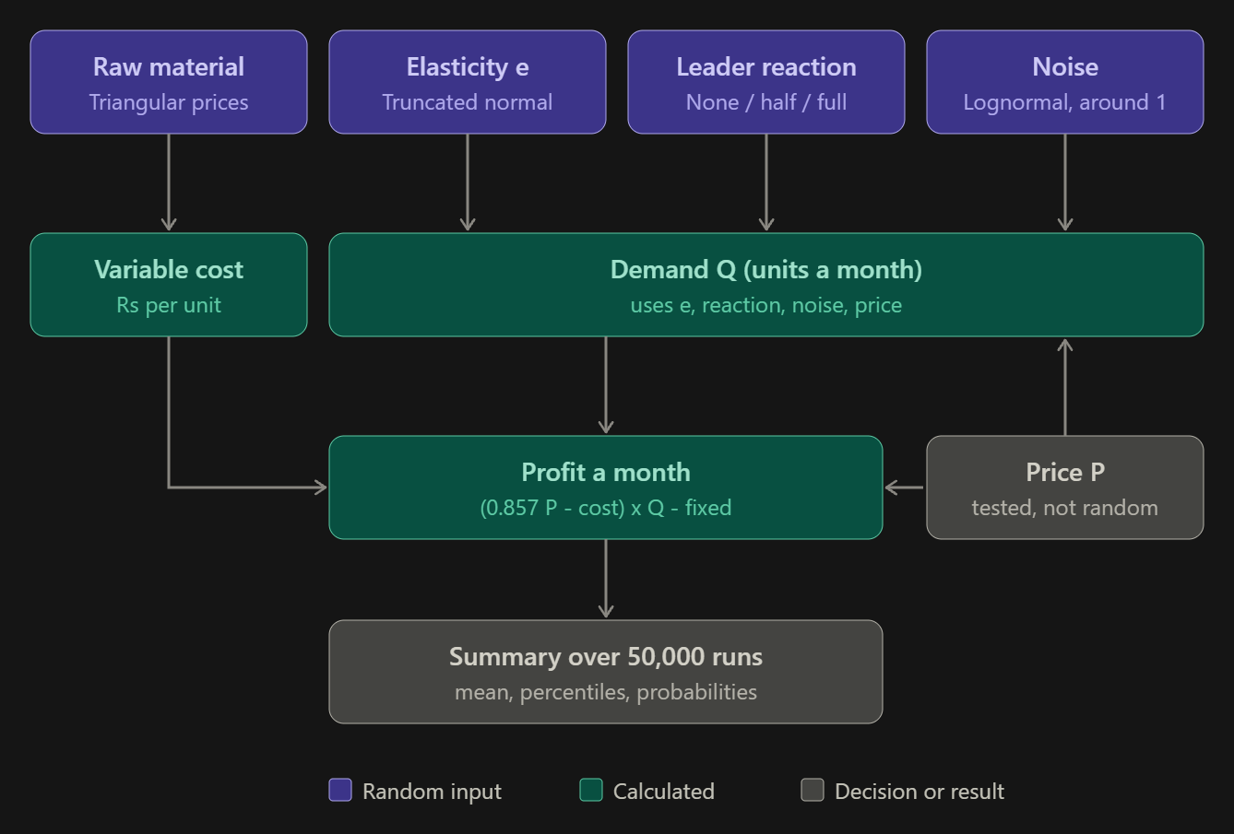

The steps below follow the boxes in the diagram. Steps 1 to 4 create the random inputs, steps 5 and 6 turn them into profit, and step 7 summarises the 50,000 results.

1. Elasticity (truncated normal)

e ~ Normal(mu = -1.116, sigma = 0.268), kept only if -3 <= e <= -0.5

The truncated density is the normal curve rescaled to fit the limits:

f(x) = phi((x - mu)/sigma) / ( sigma * [Phi(b) - Phi(a)] ), a = (-3 - mu)/sigma, b = (-0.5 - mu)/sigma

phi is the normal curve and Phi its cumulative area. The code draws from it with truncnorm.rvs.

2. Raw material prices (triangular, correlated)

Each material has a minimum lo, a most likely value m and a maximum hi.

Draw two independent standard normals z1, z2, then link them: z2' = 0.5*z1 + sqrt(1 - 0.5^2) * z2.

Convert each to a uniform number u between 0 and 1 using the normal cumulative function, u = Phi(z).

Convert u to a price with the triangular inverse formula. With c = (m - lo)/(hi - lo):

if u < c: price = lo + (hi - lo) * sqrt(c*u)

otherwise: price = lo + (hi - lo) * (1 - sqrt((1 - c)(1 - u)))

Cost per unit: RM = 0.505*dal + 0.115*besan + 0.350*oil + 0.030*spices, with prices in Rs per kg.

Variable cost: VC = RM + 47.5.

The 0.5 correlation applies to the normals. After the triangular transform, the correlation between the actual prices is slightly lower than 0.5.

3. Leader reaction

r = 0, 0.5 or 1 with probabilities 40%, 40%, 20%

leader_new = 260 - r * max(280 - P, 0)

The leader only follows our price cuts. For P of 280 or above, leader_new stays at 260.

4. Noise multipliers

noise = exp(x1), x1 ~ Normal(0, 0.05)

base_err = exp(x2), x2 ~ Normal(0, 0.08)

Taking exp keeps each multiplier positive and centred near 1, because exp(0) = 1.

5. Demand

Q = 13,000 * base_err * (P/280)^e * (leader_new/260)^g * noise then Q = min(Q, 17,000)

This comes from a log-log demand model: ln Q = ln Q0 + e * ln(P/280). The exponent e means a 1% price change moves demand by about e%. The leader term uses the cross-elasticity g ~ Normal(0.10, 0.10). The 13,000 is the demand-data baseline at Rs 280.

6. Profit

net price = P/1.05 * 0.90 = 0.857 * P (GST 5%, retailer margin 10% of pre-tax)

Profit = (0.857*P - VC) * Q - 4,03,000

7. Summary over the 50,000 scenarios

For each price, with profits x1 ... xN and N = 50,000:

mean = (1/N) * sum(xi)

P(profit >= 6.5L) = (1/N) * count of scenarios where xi >= 650,000

P(units >= 12,350) = (1/N) * count of scenarios where Q >= 12,350

5th / 95th pct = values below which 5% / 95% of sorted profits fall

Worked example: one scenario at Rs 270

This is my hand arithmetic for one illustrative draw, not output from the script.

Draws: e = -1.5, reaction r = 0.5, g = 0.10, base_err = 1.03, noise = 0.98, with prices of dal 95, besan 72, oil 108 and spices 410.

Cost: 0.505*95 + 0.115*72 + 0.350*108 + 0.030*410 = 106.36, so VC = 106.36 + 47.5 = 153.86.

Leader: 260 - 0.5*(280 - 270) = 255.

Demand: 13,000 * 1.03 * (270/280)^-1.5 * (255/260)^0.1 * 0.98 = 13,390 * 1.0561 * 0.9981 * 0.98, which is about 13,831 units. That is below the 17,000 cap.

Profit: (0.857*270 - 153.86) * 13,831 - 403,000 = 77.57 * 13,831 - 403,000, which is about Rs 6.70 lakh.

Checks: profit is at least 6.5 lakh (yes) and units are at least 12,350 (yes). This scenario therefore counts toward both probabilities at Rs 270.

The same draws are then run again at 265, 275, 280 and 285. Repeat this 50,000 times, and the share of scenarios that pass each check becomes the probability.

A correction to my earlier precision numbers

Earlier I said the Monte Carlo error was about ±0.2 percentage points for a probability near 50%, and about Rs 0.006 lakh for the mean. Those are one-standard-error figures. The usual 95% bands are about twice as wide:

standard error of a probability = sqrt(p(1 - p)/N) -> 95% band of about ±0.4 points at p near 50%

standard error of the mean = std / sqrt(N) -> roughly ±0.01 lakh for mean profit

Both are still small next to the uncertainty in the assumptions. The 0.01 figure is my estimate from the printed 5th and 95th percentiles, not from the script.

15. Deliverables

File | Purpose
pricing_workbook_fixed.xlsx | Corrected master workbook with checks and change log
bhujia_constraints_sheet.xlsx | Constraints, competitive sheets, synthetic data and Excel elasticity
elasticity_regression.xlsx | Weekly log-log regression with festival dummies
synthetic_demand_weekly.csv | Synthetic weekly demand data
monte_carlo_pricing.py | Monte Carlo profit simulation
timesfm3_price_pipeline.py | Optional TimesFM-3 baseline forecast and backtest

Appendix: key assumptions
- True own-price elasticity in the first synthetic data: -1.3 (hidden); the later corrected data may differ.
- Leader reaction mix: 40% no match, 40% half match, 20% full match.
- Monthly demand noise 5%; leader price noise 3%; raw-material ranges as in section 4.
- Festival multipliers, wedding-season (+8%) and summer (-8%) effects are assumed.
- GST at 5% and the MRP of ₹280 are to be confirmed against the product pack and the current official rate schedule.
- Here is the exact equation for Overall Profit structured completely in terms of units and volumes:
- \(\text{Overall\ Profit}=\left[\text{MRP}-\left(\frac{\text{Fixed\ Cost}}{\text{Units\ Sold}}\right)-\text{Variable\ Cost\ per\ Unit}-\text{Tax\ per\ Unit}\right]\times \text{Units\ Sold}\)

- Step-by-Step Unit Values
- By converting every financial line item from your spreadsheet into its per-unit value relative to units sold, we get the following structural blocks:
- MRP (Revenue per unit): ₹280.00
- Fixed Cost per unit sold: ₹28.7857 (₹4,03,000 / 14,000)
- Variable Cost per unit: ₹178.20
- Tax per unit sold: ₹13.35 (₹1,86,900 / 14,000)

